South West Region – Licence Meet Policies & Guidelines
Updated 28/01/2025

Blackout Dates within the Region
Any SWR LICENCED competition falls under the term ‘Blacked out’ this means the Region will not Licence any meet from L4-L1 on any date the Region has chosen. The Region will give as much notice as possible of these dates. However, should the Region need to change a date they can ask the club to change their dates as long as at least 120 days (four months) notice is given to the Club concerned.
Blackout Dates within a County
No Club should be granted a Licence to run a L1-3 meet during the County Black Out Dates which are Week 1-8 (January-February). A Club can run a single L4 meet during these weeks as long as it does not impede on anything your County is running – this does not apply to what neighbouring Counties are doing. It is to protect your Counties competitions.
County Allocation of Licenced Meets
Each County can allow the following number of Licenced meets within County per month
Maximum of 3 meets per month per county from L1-LL4 in a 4 weekend month and 4 in a 5 weekend month.
Level 4 Single/ Duel (2) Club Meet = Any amount, clubs are expected to staff their meets with their own officials.
In the month's where County or Regional Licenced Events are being run the allocation of meets per county per month should be reduced to reflect the weekend not being available.
Example 1 - January & February are County months so no meets will be Licenced except single club L4 and these must be after the Home County events are finished.
Example 2 - May SWR Summer Competition - in 2026 there are 5 weekends with two being used for SWR Competitions so there will be 2 weekends allocated for County LL4-L1 meets to be run.
Please could clubs be considerate of dates where other clubs have historically run meets year on year and not try to gazump these dates from other clubs. County Reps and the RLO can and will refuse meets if necessary. All meets should be booked onto the County Calendar via the County Licencing Rep.
The County Rep does not apply for your Licence or have the final say in issuing your club it’s Licence. They are there to help control the number of meets in the County your club is affiliated to each month.
You must not bypass your County Rep they are the first stop.
County | Representative | Rep's Email Address
Cornwall County ASA | Rosie Gordon | rosie@philipgordon.org
Devon County ASA | Martin Walters | licencing@devonswimming.org.uk
Dorset County ASA | Di Gibbs | dorsetasa@gmail.com
Gloucester County ASA | Keith Smith | gcasacompliance@gmail.com
Somerset County ASA | Kelly Podbury | somersetasa@gmail.com
Wiltshire County ASA | Sandra Yeoman | sandra.yeoman1@btinternet.com
Process for Licencing
- Check Date availability with County Rep
- Check Pool Availability & Book
- Send Licence Application & Meet Pack/Conditions to SWR RLO – Lesley – glleffers@btinternet.com
- Await Email from Swim England with Licence number.
Meet Licence Application
Applications must be received by the RLO at least 60 days prior to the meet date. The application must be on the attached form 0) Licence Application Form. I will not Licence a meet if I do not get 60 days’ notice or on the correct form. The form should be emailed in word doc format (Not PDF or JPEG). The form content must not be amended or edited – This is forwarded to Swim England by the RLO. If applying for a Level 4 Licence the application must be accompanied by a payment of £25.00 (this is for the year of competition not a 12 month period – so payments are due for any L4’s for the current year January – December.
Clubs should check with their County Coordinators to plan the meet calendar for all L1, L2, L3 & LL4.
LL4 meets must be only attended by up to 8 teams including your own team.
A County can decide how many meets a club can run a year. No club must be given priority at the detriment of other clubs wishing to run meets.
First Come First Serve meets seem to be the favourite way to go for L3 meets. However, this really is causing issues for swimmers getting into meets with little or no control for the RLO to know if this is being done fairly and
properly. So, from 2026 only 1 First Come First Serve meet per County per month will be allowed and clubs may only run one First Come First Serve each, per calendar year (January - December). Clubs must initially make it clear to the County Rep which of their meets will be FCFS and the RLO will keep an eye on this and mark those meets on her calendar.
Qualifying Times - Qualifying times must respect the level of the meet. Any times deemed to be set incorrectly will be retuned for amendments. Level 3 for County & Regional qualification Level 1 & 2 for Regional and National Qualification. I can and will refuse the application if you do not respect the level of your meet.
Accepting / Confirming Entries - NB: There is no longer a maximum hours of racing per day. However please be sensible and consider the length of time you expect your Officials, Coaches and Swimmers to spend on poolside! Advice on meet timings - Event timings should be using 45 seconds between heats and 60 seconds between backstroke heats. If your session is due to run over the allowed three hours, you must plan in a schedule break - 15 minutes must be the minimum comfort break time
Post Meet Reports – Please do not send me PDFs of Handwritten Documents, some are so hard to read, I am happy with typed signatures. The PROMOTER must return ALL the attached reports to the RLO as one communication, this includes the proof of payment screen shot. They must ALL come from the Promoter only at the same time, not all over the place on different dates and from different people please. It makes life really hard trying to track everything.
0) Promoter Report SWR - within 14 days of the meet finishing - Typed and emailed as a word doc by the Promoter or scanned or photo shot forms emailed. Do not send in post
0) Referee Report SWR - within 14 days of the meet finishing - Typed and emailed as a word doc by the Promoter or scanned or photo shot forms emailed. Do not send in post
0) Technical Officials attendance Sheet SWR - within 14 days of the meet finishing - Typed and emailed as an Excel doc by the Promoter - emailed please. Please do not send in post or send handwritten documents as I use a formula to check & some peoples handwriting is difficult to read. Please do not delete hidden column C.
Results to Rankings - These must be with Rankings within five days of the meet finishing rankings@swimming.org Please note that any overdue submissions could result in the times being rejected by Rankings.
Laws – We are now swimming - Under Swim England Laws and Regulations and Swim England Technical Rules of Racing
Data Protection Statement - Entries may be held on a computer solely for the purposes of this competition and consent, as required by the Data Protection Act 2018 and in line with GDPR 2018, to the holding of personal information on computer will be deemed to have been given by the submission of the entry. Personal Data will be available for inspection during the Meet on application to the Promoters. If you meet entries are being processed by a third party, please ensure you say that in your conditions.
Photography & Video Recording - In line with Swim England & Wavepower guidance, Anyone wishing to take images (photo or video) are requested to focus on their own children as much as reasonably possible and to avoid including other children in images, particularly if those images are being shared with family and friends or through social media platforms. It must be noted in your conditions that mobile phones or image capturing devices must not be used or open in the changing rooms or changing area’s.
The full Swim England guidance on Photography can be found in Wavepower, the Swim England Child safeguarding policy and procedures, available at http://www.swimming.org/swimengland/wavepower-child-safeguarding-for-clubs/
Secondary Strobe - From September 2023, all meets licensed at Levels 1, 2, 3 must provide a secondary strobe where it is requested by an athlete at the time of entry. There is no requirement for Level 4 meets, but it must be stated if there is or is not a secondary strobe.
Disability – Para Swimming - Disabled swimmers should be accepted into all and any Licensed meet if requested to do so. All Meets should have an applicable Disability condition – Example:
Disability Swimmer entries - All swimmers must have an authorized SE/IPC swimming classification, Certificate of Disability or Certificate of Exception. In addition, details of disability must be provided with entry. Please ensure you present, Certificate of Disability or Certificate of Exception to the Referee prior to each competition session, failure to do so may result in disqualification. Please also see the attached - licensing of swim meets with World Para-Swimming. Also state in your conditions if you are awarding medals to Disability swimmers separate to the able bodied category.
Transgender Policy - The Female category is for birth sex females in accordance with Swim England’s Transgender and Non-Binary Competition Policy. By entering the ‘Female’ category, a swimmer confirms that their birth sex is female.
Paying your Levy fees – To be Paid within 14 days of the meet finishing
Your fee can be paid by transfer to the following account: -
Bank - Lloyds Bank Account Name - Swim England South West Limited
Sort Code - 30-98-97 Account No - 34605163
Please name payment as – Club and Level ie: Dorset ASA L2
Please take a screen shot of the payment and send to your promoter who will email to me.
Level 4 - £25.00 per year – Jan to Dec in that year – One off payment
Low Level 4 & Level 3 - £0.20p per entry swim (not per swimmer)
Level 2 & Level 1 - £0.35p per entry swim (not per swimmer)
Please pay your post meet Levy by bank Transfer - a screen shot from the Promoter of the levy fee payment from the Clubs bank to SE SWR account. Lloyds TSB SE South West Region Sort Code - 30-98-97
Account No - 34605163. Please name payment as – Club and Level ie: PL L1 May22.
Screenshots of the payment must reach the RLO within 14 days of the meet finishing. Along with all other required documents.
Protect your club - We have had several failures of meets in the SWR due to many different reasons. Protect your club and add a clause covering failures and refunds should these occur. Suggestions may be something like the below:-
1. The Meet Promoter will make every effort to run the event. In any situation that the meet must be cancelled competitors are not eligible for full refunds of their entry fees. Proportionate refunds may be made but only after the promoter has covered all incurred costs.
2. The Meet Promoter will make every effort to run the event at the advertised licence level. In any situation that the meet must be run at either unlicensed or at a lower licence level, competitors are not eligible for refunds of their entry fees.
Licensed Meets - Officials Staffing
All Qualified Officials including those who have swimmers entered into the meet, MUST be offered reimbursement for their travel costs to and from your meet. The standard rate is 0.45 per mile. This must be added to your conditions. You should have a reimbursement form for Officials at your meet office/desk and they will need to get this signed off by the Referee in order for payment to be made by you. Most officials will not apply. NB: This does not apply to Trainee Officials.
Promoting Clubs can now request Officials from entering clubs as a condition of entering, for example one qualified official for every 10 swimmers entering per session. It is up to the club if they choose to enforce this if a club is struggling to meet the condition. However, we have had several failures of meets due to poor or inadequate staffing of meets by officials for the level of Licence. Please be aware this cannot be tolerated. With All major events be ranked time driven the times going to rankings must have been at meets where the correctly qualified officials are in place. Any meet that does not meet the correct standard will result in the meet being downgraded or loose it’s Licence. Please see below for the correct expectations from Swim England for your Licensing. Officials must now be offered reimbursement for costs incurred to officiate at your meets. Please add this condition.
Officials Qualifications
Please see the first tab of the 0) Technical Officials attendance Sheet – (dated 040524) To ensure you have the correct cover of officials at the meet you are running check below and on the attached Officials return form. Forms without Full (correct) Names & SE ID numbers for your Officials will be returned. Please use my Excel document attached (0) Technical Officials attendance Sheet - SWR) as I use a formula to check them. This must be returned in the Excel format, not PDF or hand written screen shots please. Do NOT delete hidden column C
Do not be offended if I ask for clarification, my lists from SE are out of date the day I receive them so sometimes I do need to check official’s qualifications. Keeping my lists up to date prevents me bothering you next time.
Jill Beard - SESW Regional Officials Training and Development Coordinator – does not get updates on Stand Alone Timekeepers so you must keep both her and me up to date with newly qualified TK. If they do not show on the list from SE that I receive it will be because they have not uploaded their passes onto their profile, and I will have to ask for clarification. Jill has kindly given me the process you should follow:-
It is of course important to get the certificates uploaded as soon as possible as well.
So, everything can be as prompt as possible I enclose 1. How to upload certificates 2. A template that can be used to show timekeeper competency. The TK certificate can be authenticated by the person who observed the competency who must be at least a J1.

Congratulations you have successfully completed the online learning
If you are a member of Swim England or Swim Wales, you need to upload a copy of your certificate (or competency page) to https://swimmingresults.org
- Register (You only need to do step 1 once) at https://swimmingresults.org/member_options/register.php, using the email address on your membership record
- Log in at https://swimmingresults.org/member_options
- Once logged in, select the following options within the website:
- To view or upload a copy of listed certificates to be added to your membership record select here (within the website)
- To upload a new certificate, select here (within the website)
- Use the Certificate Type drop down menu to choose Swimming J1 Theory ( TK Theory; Timekeeper practical or J1 practical as appropriate)
- Select Certificate
- Select Choose File
- Add the date as shown on your certificate
- Select Upload Certificate
( Jill Beard - SESW Regional Officials Training and Development Coordinator)

Could I ask Officials if they would consider making their qualifications visible on their personal ID on OMS. The process is very simple; however, this is the Officials own choice to do this.
Show Qualifications & Certificates
Please go to https://www.swimmingresults.org/membershipcheck/
search your membership using your member ID
Click on - Member Options
Login in using your Member ID and Password
Click on - Online Membership System
Click on - Login in as Member
Click on - Edit Details
Click on - Data Protection Choices
Click yes in all boxes except the last four. If Disability does not apply say no. You do not want any personal info such as address and email/telephone numbers showing so say no.
Click Save

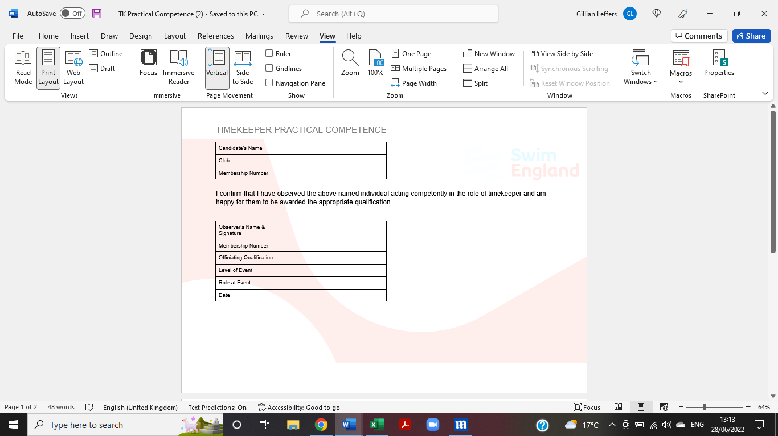

MINIMUM REQUIREMENTS
LEVEL 1 and 2
All Officials are required to be qualified and licensed for the role to which they are appointed.
Referee [2]
Starter [1]
Judge of Stroke [2]
Chief Inspector of Turns [2]
Timekeeper/Inspector of Turns (start end) [1 per lane]
Inspector of Turns (turn end) [at least 1 per 2 lanes] i.e a pool with 8 lanes in use requires at least 4 Inspectors of Turns at the turn end
LEVEL 3
At least one qualified, licensed Referee shall be appointed for each session.
Referee [1] – Licensed and qualified as a Referee. Any additional officials acting in the role of referee should be qualified to at least J2(S)
Starter [1] – Qualified to at least J2(S)
Judge of Stroke [2] – Qualified to at least J1
Timekeeper/Inspector of Turns (start end) [1 per lane] – a minimum of J1 in training (see definition below)
Inspector of Turns (turn end) [1 per 2 lanes] - a minimum of J1 in training (see definition below) i.e. a pool with 8 lanes in use requires at least 4 Inspectors of Turns at the turn end, all of whom must be at least J1 in training
LEVEL 4
At least one qualified, licensed J2S or Referee shall be appointed for each session.
Referee [1] – Licensed and qualified to at least JL2S. Any additional officials acting in the role of referee should be qualified to at least JL2S
Starter [1] – Qualified to at least J2
Judge of Stroke [2] – Qualified to at least J1
Chief Timekeeper [1] – At least J1 in training (see definition below)
Timekeeper/Inspector of Turns (start end) [1 per lane] – At least qualified Timekeeper
Inspector of Turns (turn end) [1 per 2 lanes] – a minimum of qualified Timekeeper
i.e a pool with 8 lanes in use requires at least 4 Inspectors of Turns at the turn end, all of whom must be at least qualified Timekeepers
Judge Level 1 in training
In order to act as a “Judge 1 in training” for meet licensing purposes the individual must:
· Have enrolled on the Judge 1 course and completed all of the online theory modules
· Have evidenced achieving practical competence as a timekeeper
· Be within the requisite period of completing their poolside competencies

