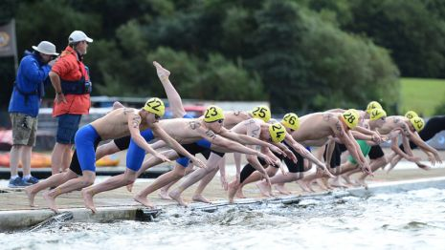

SWIM ENGLAND SOUTH WEST REGION
OPEN WATER SWIMMING 2018

SWIMMERS’ DEVELOPMENT COURSE

A COURSE TO INTRODUCE SWIMMERS INTO THIS GROWING DISCIPLINE OF OUR SPORT AND TO DEVELOP SKILLS FOR OPEN WATER SWIMMING

A TWO DAY COURSE – 26th May 2018 and 2nd June 2018

(Ages 12 to 17 years)

PART 1 – Saturday 26th May 2018 at Wells Leisure Centre, Somerset, BA5 2FB
12.30 – 19.00: - WORKSHOPS, LAND TRAINING & POOL EXERCISES

PART 2 – Saturday 2nd June 2018 at Vobster Quay, nr Frome, Somerset, BA3 5SD
09.30 – 16.45: - OPEN WATER SWIMMING SKILLS AND PRACTICE

For more details please CONTACT:
Kat Percival – South West Region Open Water Coach
kat.percival@outlook.com

Course Fee (both days): £65.00 per swimmer
(incl. packed lunch on 26th May)
ADVANCE NOTICE
OPPORTUNITIES TO QUALIFY FOR SWIM ENGLAND NATIONAL OPEN WATER CHAMPIONSHIPS

DISTANCES: 5 KM, 3 KM, 2 KM plus 1 KM Taster Event for 11 -13 yrs
Saturday 7th July 2018 at Preston Beach, Weymouth

Put this date in your diaries and watch for entry details on the
Swim England South West website

Swim England South West Region website

